Media Contact:
Sarah Wynn Benton
BRAVE Public Relations
sbenton@emailbrave.com
FOR IMMEDIATE RELEASE

Jay Shetty, Global Bestselling Author & Award-Winning Podcast Host, is Coming to Atlanta on First Ever World Tour “Jay Shetty: Love Rules” March 1 at Atlanta Symphony Hall
Tour Will Follow the Release of Jay’s Highly Anticipated Second Book, ‘8 Rules of Love,’ Out Jan. 31

Tickets On Sale Now at Ticketmaster.com
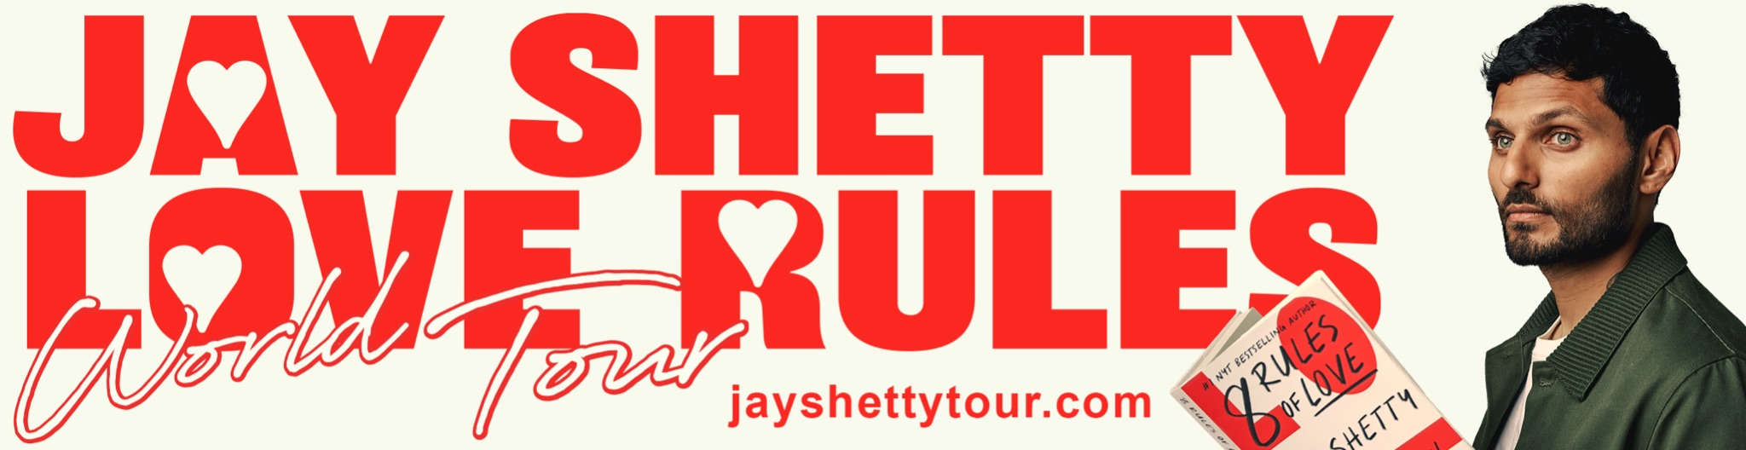
Approved imagery available for download HERE.

ATLANTA, GA (December 13, 2022) – Global bestselling author and award-winning podcast host, Jay Shetty, has announced his first ever world tour, Jay Shetty: Love Rules, which will come to Atlanta Symphony Hall on March 1, 2023. In a 90-minute experience, Jay will take the audience on a journey of finding, keeping, and even letting go of love, including live meditations, experiments and demonstrations. Tickets and VIP packages are on sale now at ticketmaster.com. The full tour route and additional information is available at JayShettyTour.com.

“I have waited for this moment for years. I am so excited to be headed on tour to connect with my incredible community in person, to share space and energy. I promise you it will be an unforgettable experience,” said Jay Shetty. “To me, love is truly a universal language and evolving practice in which we can all learn and grow from together. The opportunity to share what I’ve learned about love from my studies in ancient wisdoms, modern science, and personal experiences is something I am very grateful for.”
The live tour kicks off after the release of Jay’s second book, 8 RULES OF LOVE: How to Find It, Keep It, and Let It Go out on Jan. 31, 2023. In the book, Jay, the author of global bestseller THINK LIKE A MONK, offers a revelatory guide to every stage of love, drawing on ancient wisdom and modern science. Jay Shetty: Love Rules isn’t Jay’s first time on stage, previously he held a one-night only show in Nov. 2019 at the Ace Theater in Los Angeles, CA, where tickets sold out immediately at the on-sale.

About Jay Shetty
Jay Shetty is a global best-selling author, purpose coach, former monk, host of the #1 Health & Wellness podcast “On Purpose,” co-founder of Sama Tea, and Chief Purpose Officer of Calm.

Jx=under his belt. In 2019, AdWeek dubbed him a Young Influentials cover star, describing him as “an emanation of spiritual force.” In 2017, Forbes named him to the 30 Under 30 List for being a game changer in media. People Magazine has named him “one to watch.” In 2018 and 2019, the Streamy’s named him the Best Health & Wellness Creator of the Year. His videos have been viewed more than 10 billion times and he is followed by over 50 million people across social media.

In 2019, Jay created “On Purpose,” which is now the world’s #1 Health & Wellness podcast and its opening year ranked #1 on Spotify in India and in Apple’s Top 20 Podcasts of the Year. Guests have included talent from various backgrounds, such as Oprah, Jennifer Lopez, Kendall Jenner, Will Smith, Kobe Bryant, Alicia Keys, Novak Djokovic, Ray Dalio, among others.

In 2020, Jay authored his first book, “Think Like A Monk: Train Your Mind for Peace and Purpose Every day.” The book debuted at #1 on the New York Times, #1 on the Sunday Times and was deemed “un-put-down-able” by Amazon, where it held the #1 spot worldwide. Following the immense success and millions of copies sold of Jay’s first book, on January 31, 2023, Jay will release his second book, “8 Rules of Love: How to Find It, Keep It, and Let It Go.” Learn more at 8RulesofLove.com.

When Jay isn’t writing or making videos, he’s coaching as the founder of the Jay Shetty Certification School, a purpose driven educational institution offering accredited certifications in life coaching to individuals and organizations. He’s been a keynote speaker around the world on global stages on behalf of powerhouses like Google, Microsoft, Netflix, HSBC, and has developed corporate training programs for many of these organizational clients. His online courses have been attended by over 2 million students and his “Genius Community” provides weekly programming on the principles and practices for health and wellness to thousands of members in over 100 countries.

Born in England, Jay now resides in Los Angeles with his wife Radhi.
Instagram // Facebook // Twitter // YouTube // Website // Podcast (Apple / Spotify)

Jay Shetty
Caroline Holmberg, Paul Samaha, Nicole Perez-Krueger | align PR, teamjayshetty@align-pr.com

